Emoticon Prediction of a sentence

A Project Report

Submitted by

Puranjay Guleria Samridhi Kohli

169108110 169108125

In partial fulfilment for the award of the degree

of

BCHELOR OF TECHNOLOGY

IN

Information Technology

at



MANIPAL UNIVERSITY JAIPUR

JAIPUR

November 2019

DECLARATION BY THE CANDIDATE

We hereby declare that the work, which is going to be presented in the Project, entitled “Emoticon Prediction of a sentence” to be submitted in partial fulfilment of the requirement for the award of Degree of “Bachelors of Technology” in Department of Computer Science Engineering with Specialization in Information Technology and to be submitted to the Department of Information Technology, Manipal University Jaipur is an authentic record of my own investigations carried out under the supervision of Dr. Vivek K Verma , Assistant Professor, SCIT, Manipal University Jaipur.
We have not submitted the matter presented in this project anywhere for the award of any other degree.

Puranjay Guleria Samridhi Kohli
Reg. No. 169108110 Reg. No. 169108125

ACKNOWLEDGEMENT

The enduring pages of the work are the cumulative sequence of extensive guidance and arduous work. We wish to acknowledge and express our personal gratitude to all those without whom this work could not have been reality.

We feel very delighted to get this rare opportunity to show our profound senses of reverences and indebtedness to our esteemed Dr Vivek K Verma for his keen and sustained interest, valuable advice, throughout the course of which led our report, to a successful completion. For this kind act of consideration we be holder to them in special manner and no one can fully convey our feelings of respect and regard for him.

LIST OF FIGURES

Figure 2.1.1 | Categorization and Assignment | 8
Figure 2.2.1 | Model Used | 9
Figure 3.2.1 Output 10

TABLE OF CONTENTS

PARTICULARS |  |  | Page
Candidate’s Declaration |  |  | 2
Acknowledgement |  |  | 3
List of Figures |  |  | 4
Abstract |  |  | 6
1 | Introduction |  | 7
 | 1.1 | Background | 7
 | 1.2 | Project Motivation | 7
 | 1.3 | Aims And Objectives | 7
 | 1.4  1.5 | Implications  Roles of Team Member | 7  8
2 | Implementation |  | 6
 | 2.1 | Tools & Technology | 8
 | 2.2 | NLP Algorithms Used | 9
3 | Experimental Result |  | 8
 | 3.1 | Experiment Setup | 10
 | 3.2 | Output Snippet | 10
4 | Conclusion |  | 11
References |  |  | 12

ABSTRACT
The project deals with prediction of emoji over a sentence after processing a particular sentence.
Here we have implemented a model which inputs a sentence (such as "Let's go see the baseball game tonight!") and finds the most appropriate emoji to be used with this sentence (⚾️). In many emoji interfaces, you need to remember that ❤️ is the "heart" symbol rather than the "love" symbol. However, using word vectors, we will see that even if our training set explicitly relates only a few words to a particular emoji, our algorithm will be able to generalize and associate words in the test set to the same emoji even if those words do not even appear in the training set. This allows us to build an accurate classifier mapping from sentences to emoji’s, even using a small training set.

Chapter - 1
INTRODUCTION
  - Background
The challenge of this project is to predict emoji after looking at a sentence correctly in order to increase the effectiveness of a sentence. This is being achieved by looking at the sentence, converting the words of the sentence into numerical representation and then feeding it into our model which would predict the result.
1.2 Project Motivation
Writing an informal message is our everyday activity. We do it through various platforms such as WhatsApp. Use of Emoji’s make these messages look more expressive. So rather than writing "Congratulations on the promotion! Let’s get coffee and talk. Love you!" the model can automatically turn this into "Congratulations on the promotion! 👍 Let’s get coffee and talk. ☕ Love you! ❤"
1.3 Aims and Objectives
- Create a model, which will accurately generate emoji for a given sentence.
- To study various models and their relevance in the prediction of such emoji’s.
- To study the use of LSTM in such modeling.

1.4 Implications in system development
The challenges we faced are as follows:
- Which type of word embedding to use.
- Whether to use GRU or LSTM units.
- The number of epochs and setting the learning rate.

1.5 Roles of Team Members
Samridhi Kohli: Creating the dataset and designing the model.
Puranjay Guleria: Setting up hyper parameters and implementation/training of model

Chapter - 2
IMPLEMENTATION
2.1 Tools and technology Used
The platform we used was Spyder and the language used is python. We used python libraries such as Emoji, matplotlib and Keras in order to implement the model.
We used Keras to define our model and compile it with hyper-parameters.
We used two LSTM layers with dropout and embedding layers. We used a Softmax layer at the end to give predictions for our emoji’s.

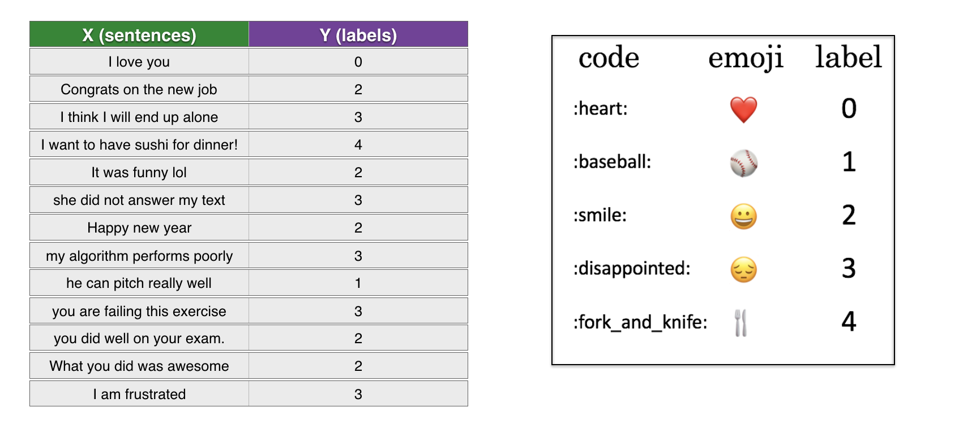
Fig 2.1.1 Categorization and Assignment
  - NLP Algorithms Used

- Recurrent Neural Network
- Glove vector representation

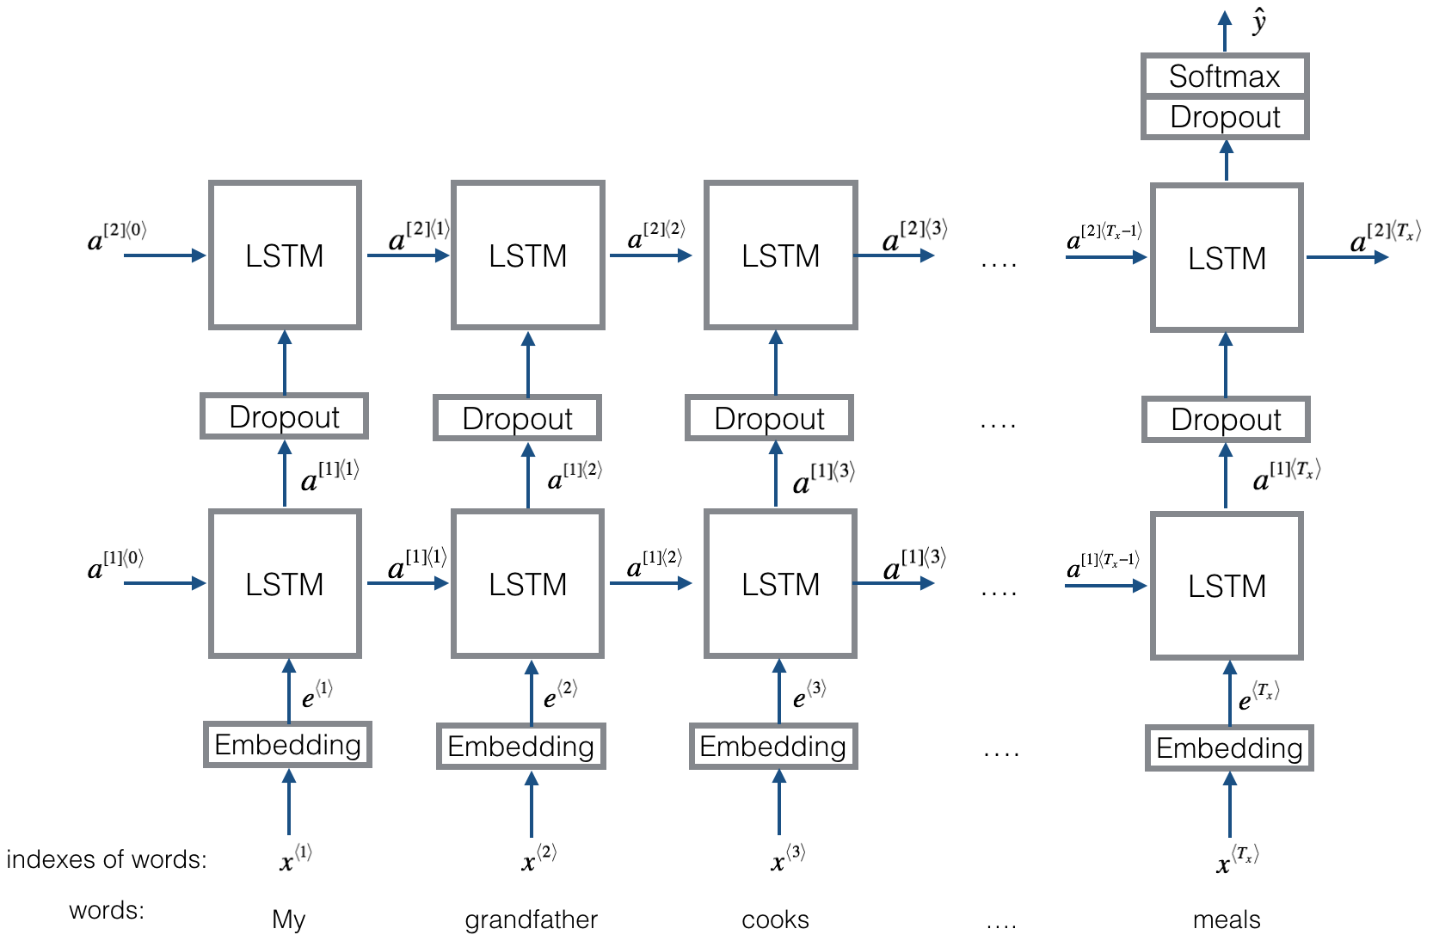

Fig 2.2.1 Model Used

Chapter - 3
EXPERIMENTAL RESULT
3.1 Technology Used
- Python
- Spyder
- Keras
- Emoji library

3.2 Output Snippet
The following is the output obtained:

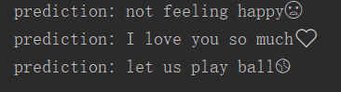
Fig 3.2.1: Output

Chapter - 4
CONCLUSION
We were able to predict the emoji for the corresponding input of sentence after training our model using LSTM neural network and minimizing overfitting and errors.

REFERENCES

Reference / Hand Books

[1] Fluent Python: Clear, Concise, and Effective Programming

Web

[1] https://towardsdatascience.com/
[2] https://en.wikipedia.org/wiki/Long_short-term_memory

